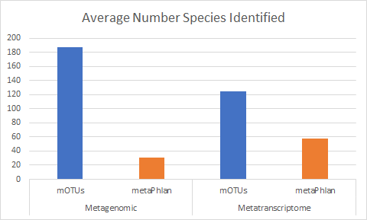

Supplementary Figure : mOTUs identifies more species from both metagenomes and metatranscriptomes relative to MetaPhlAn. This finding highlights the need to include non-reference OTUs in analysis of microbial communities.



A

B

Supplementary Figure 2: Marker gene levels are more weakly correlated in metatranscriptomes than in metagenomes. In A, we show an example of the correlation between 2 marker genes in a metagenome and metatranscriptome sequences from the same sample. The correlation is weaker in the metatranscriptome. In B, we look systematically at the Spearman’s correlations between all marker genes. The correlations are consistently weaker in the metatranscriptomes.



A

B

Supplementary Figure 3: We plotted the first two principal components of the marker gene expression levels in one metatrasncriptome. In A, we looked at whether or not there was any difference between reference and meta OTUs in their marker gene expression. This would likely be an artifact of the method, and we did not see any difference. In B, we looked for stratification along the principal components by phylum, but we did not see any widespread differences.

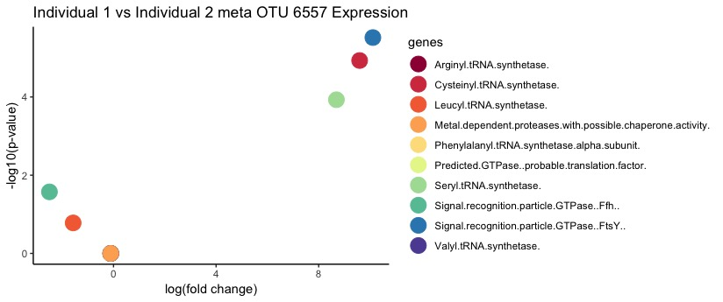

Supplementary Figure 4: We calculated p-values for differential expression of marker genes in the metatranscriptomes of two individuals using a negative binomial model implemented in edgeR. The analysis requires more replicates, but we see that there may be differential expression of marker genes across individuals, which could offer biological insight into the activities of meta-OTUs that could not be studied with previous methods.



Supplementary Figure 5: Transcript abundances captured by HUMAnN2. Our implementation of HUMAnN2 demonstrates that many reads cannot be mapped to known reference genomes, highlighting the need for tools that do not require reference genomes.